UNIVERSIDAD AUTONOMA DE COAHUILA CENTRO DE IDIOMAS US



**1ST TEST**

LEVEL 8 KIDS

STUDENT´S NAME: DATE: TEACHER´S NAME: WRITTEN GRADE ORAL GRADE

**Listening**

1. LISTEN AND MAKE A .  118

|  |  |  |  |  |
| --- | --- | --- | --- | --- |
| **1** | **2** | **3** | **4** | **5** |

2 LISTEN AND NUMBER.  119



**/ 10**

|  |  |  |  |
| --- | --- | --- | --- |
| **3.**  **1** | **Writing**  **LOOK AND WRITE.**  **The postcard is .** | **2** | **The key rings are .** |
| **3** | **The pins are .** | **4** | **The bracelet are .** |
|  |  |  | **/ 4** |

**Reading**

**4. CIRCLE AND WRITE THE ANSWERS.** IT’S THEY’RE JAKE’S ALI’S

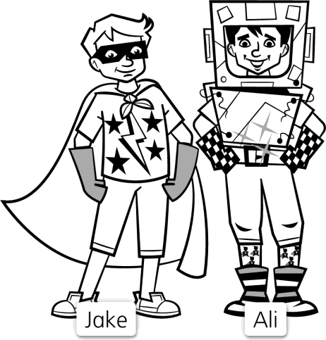

|  |  |  |
| --- | --- | --- |
| **1.** |  | **Whose plain gloves** is **/** are **they?** |
| **2.** |  | **Whose shiny belt** is **/** are **it?** |

**/ 6**

**Vocabulary**

1. **READ, CIRCLE, AND COMPLETE.**

SHARE DIG DRIVE TEACH SHOUT STUDY

|  |  |  |  |  |  |
| --- | --- | --- | --- | --- | --- |
| **1** |  | **He’s / She’s**  **.** | **2** |  | **I’m / They‘re**  **.** |
| **3** |  | **We’re / He’s**  . | **4** |  | **She’s / We’re .** |
| **5** |  | **She’s / He’s .** | **6** |  | **They’re / He’s .** |
|  |  |  |  |  | **/10** |

**Grammar**

1. LOOK AND NUMBER. COMPLETE WITH ***MUST*** OR ***MUSTN’T***.

|  |  |  |
| --- | --- | --- |
|  | **1** | **You eat in the library.** |
| **2** | **You carry a lot of books.** |
| **3** | **You share books.** |
| **4** | **You whisper.** |

**/ 8**

**Writing**

**7. Draw and describe your favorite character.**

**/12**

**TOTAL POINTS 50**